Amazon S3 allows you to host static websites (HTML, CSS, JavaScript) without needing a web server.

**Go to the AWS S3 Console:**

* Open the [Amazon S3 Console](https://s3.console.aws.amazon.com/).

**Click "Create bucket".**

**Enter a unique bucket name** (e.g., my-static-site).

**Choose a region** close to your users.

**Disable "Block all public access"** (for public websites).

**Enable "Bucket Versioning"** (optional for backups).

Click **"Create bucket"**.

And upload the index.html

Open your **S3 bucket**.

Click **"Upload"** → **Add files** (HTML, CSS, JS, images).

Click **"Upload"**.

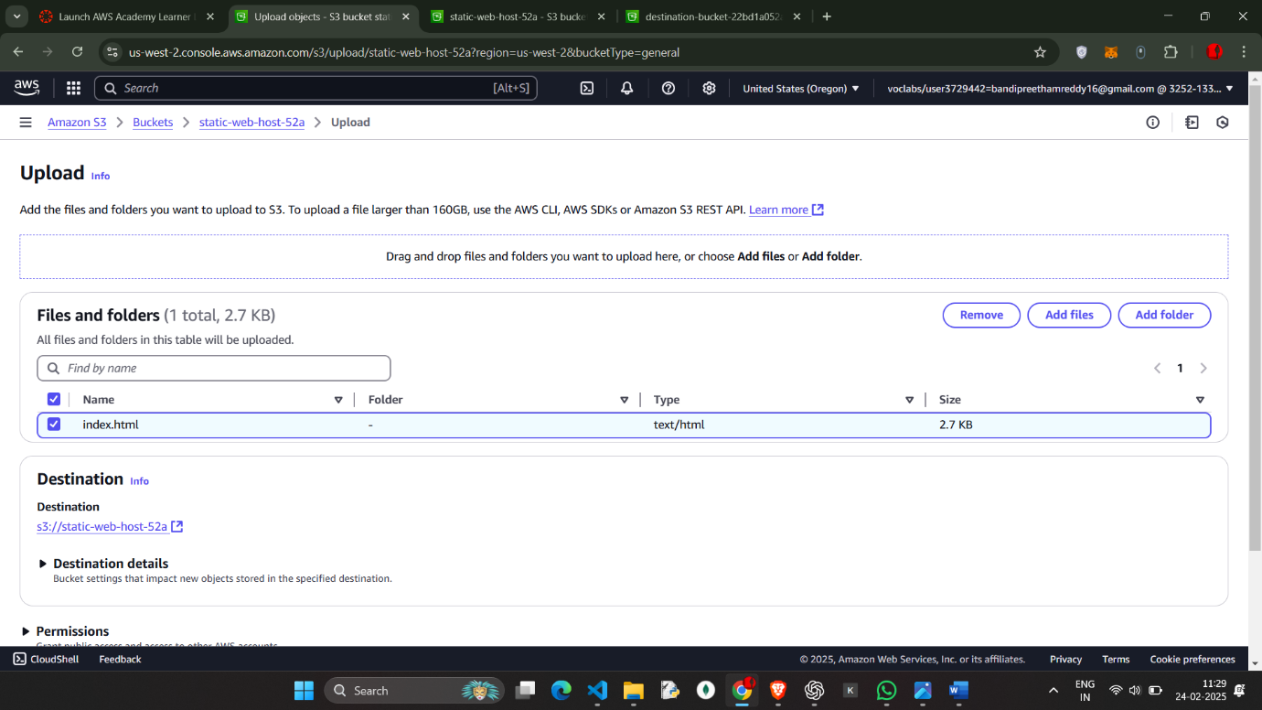

Go to permission and edit the static web hosting

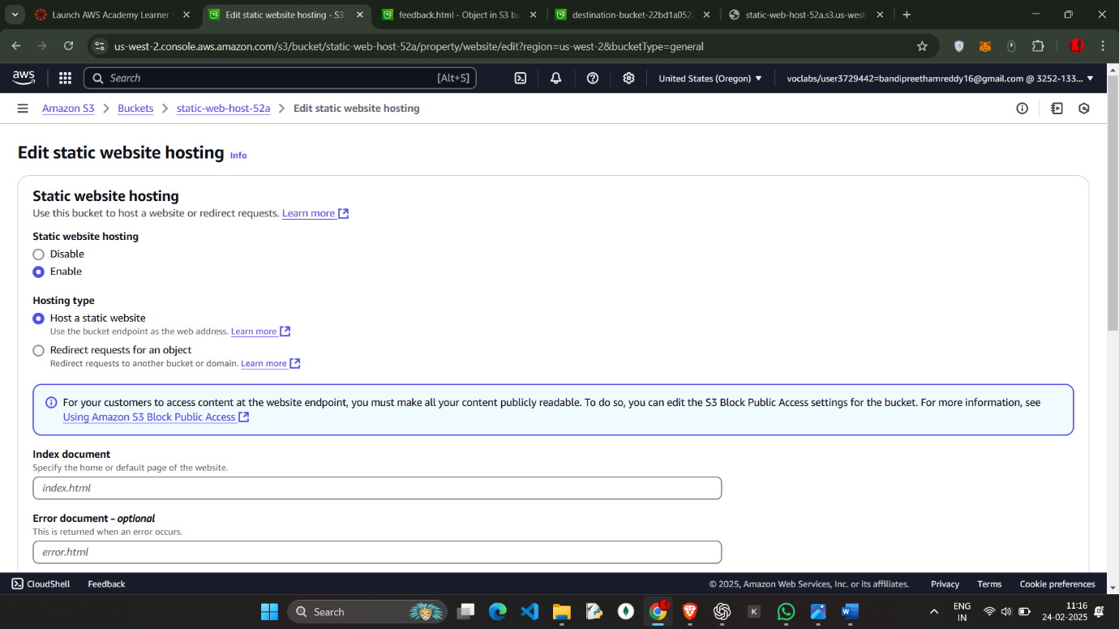

Go to **Bucket Properties**.

Scroll to **"Static website hosting"**.

Select **"Enable"**.

Choose **"Host a static website"**.

Enter **Index document:** index.html.

(Optional) Enter **Error document:** error.html.

Copy the **endpoint URL** (this is your website URL).

Click **Save changes**.

**Make Files Public**

1. Go to your **S3 bucket → Objects**.
2. Select all files → Click **Actions** → **Make public**.
3. Confirm the changes.
4. 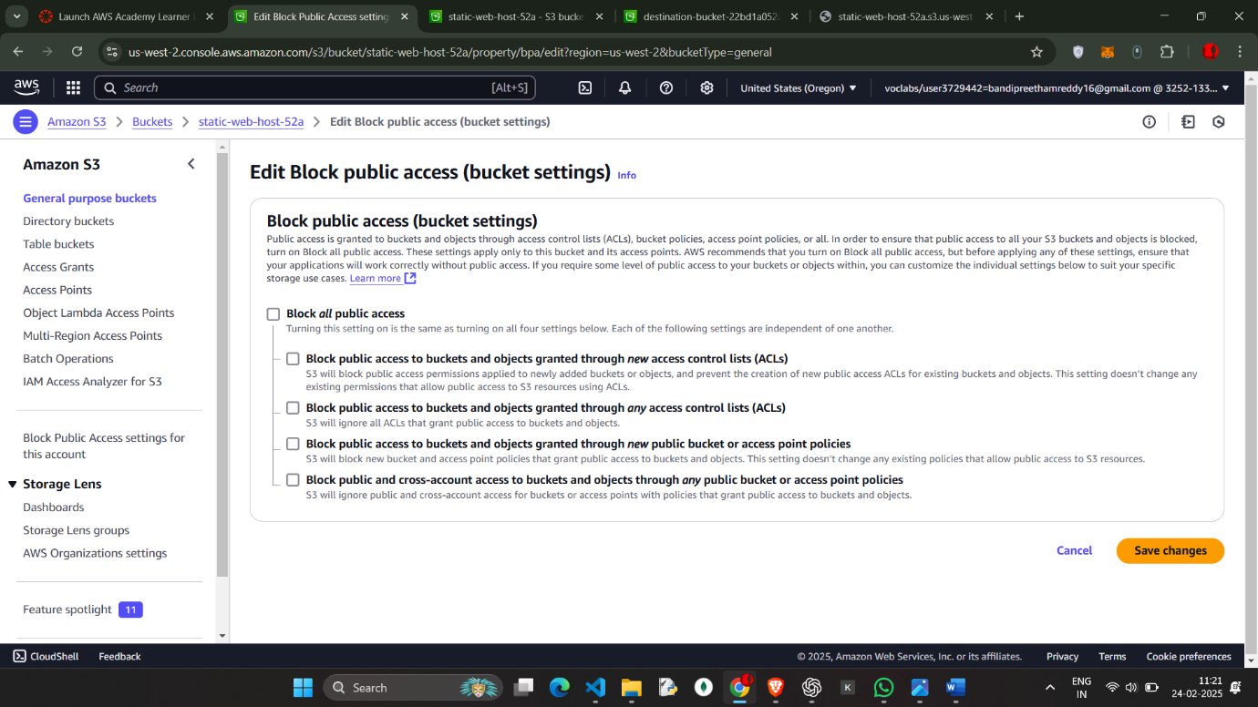

SAVE ALL THE CHANGES

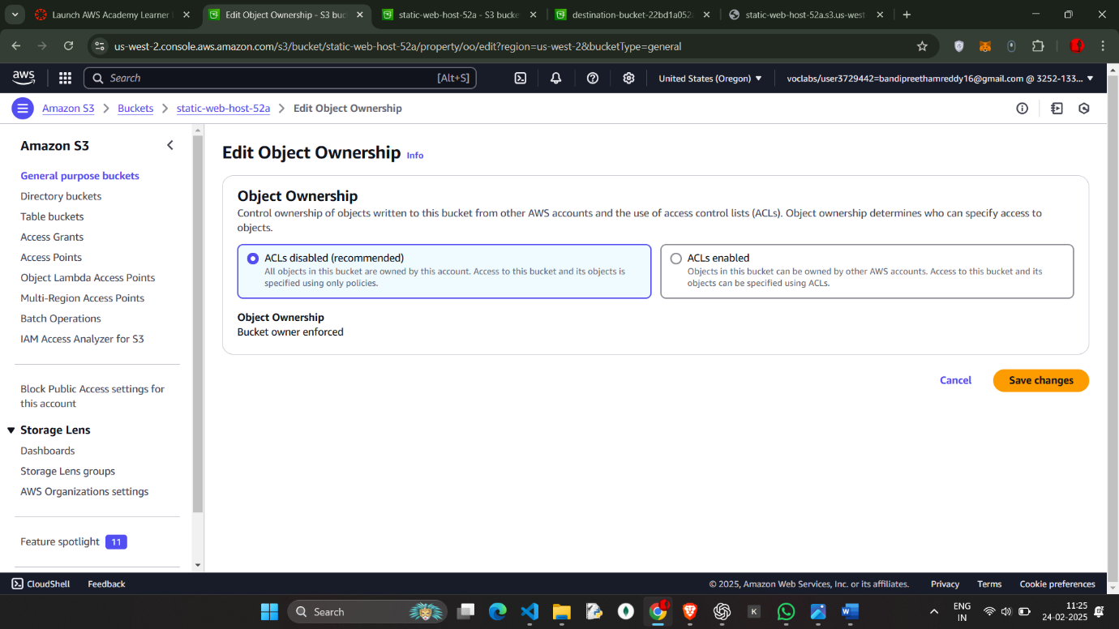

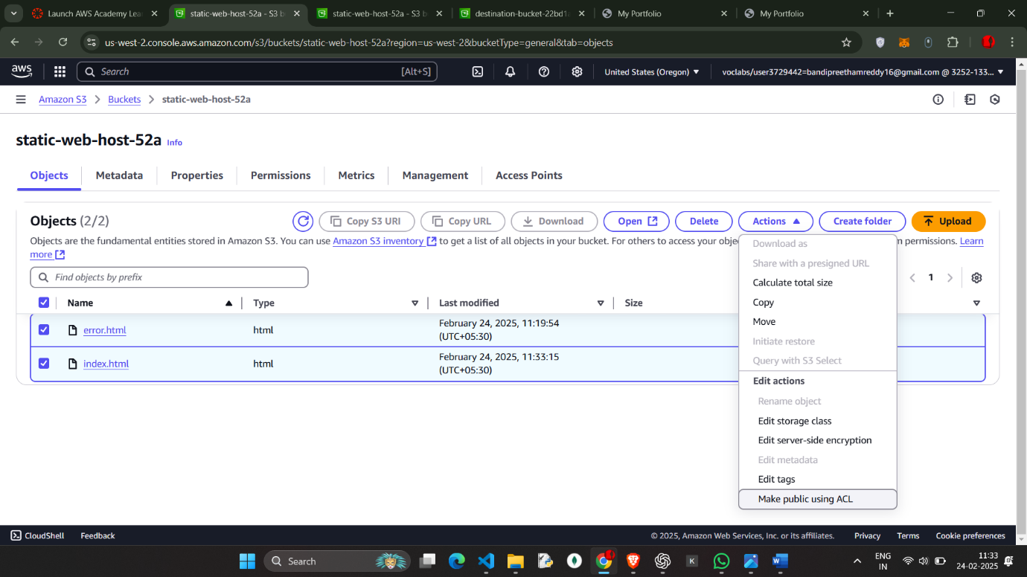

Make Public using ALC

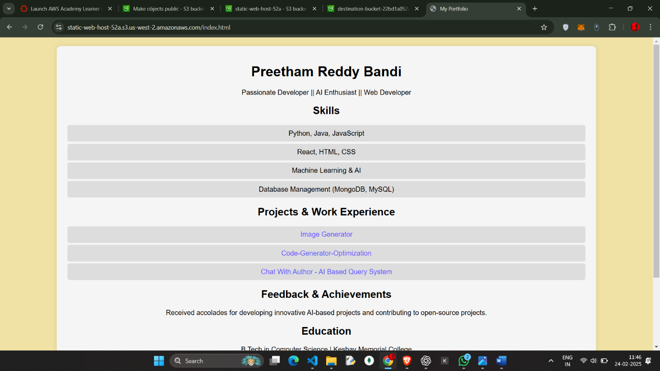  
  
Link : https://static-web-host-52a.s3.us-west-2.amazonaws.com/index.html